📋 SESSION 01 WORKSHEET
Student Name: Nguyễn Thu Hồng Student ID: 22071101
Date:12/10/2003 Class: MIS2022B

PART A: KNOWLEDGE SUMMARY

A1. Key Concepts
Concept | Definition (In your own words) | Example
PHP | PHP is a server-side programming language used to create dynamic websites and process data on the server. | <?php echo "Hello"; ?>
echo | Echo is a statement used to output data to the web browser. | echo "Hello World";
Server-side | Server-side refers to processing that happens on the server before the result is sent to the user's browser. | Processing form data using PHP

A2. Multiple Choice Questions
1. What does PHP stand for?
Answer: B) PHP: Hypertext Preprocessor
2. What is the correct PHP opening tag?
Answer: B) <?php
3. PHP statements end with?
Answer: C) Semicolon (;)

A3. Essay Questions
1. Explain the process from when the user enters a URL until the webpage is displayed.
Answer:
When a user enters a URL, the browser sends a request to the web server.
The server processes the request, executes PHP code if available, and generates HTML content.
Finally, the server sends the HTML output back to the browser, and the browser displays the webpage to the user.

2. Why should we use echo instead of print?
Answer:
Echo is faster than print and can output multiple strings at the same time.
Echo does not return a value, while print returns a value, so echo is commonly used to display output in PHP.

PART B: THEORY EXERCISES

EXERCISE 1: Fix Code Errors
Original code (contains errors):
<?php
echo "Hello World"
echo "Welcome to PHP!";
print "This is", "PHP";
?>
Corrected code:
<?php
echo "Hello World";
echo "Welcome to PHP!";
print "This is PHP";
?>
Explanation:
- A semicolon was missing after "Hello World".
- The print statement does not support printing multiple strings at once.

PART C: PRACTICAL EXERCISES

PRACTICAL EXERCISE 1: Personal Information Page
🎯 Objective: Create a page displaying personal information
📝 Requirements:
- Create file myinfo.php
- Display: Full name, Date of birth, Hometown, Hobbies
- Beautiful CSS
- Display access date and time
📤 Expected Result:
- Webpage displays complete information
- Beautiful, readable interface
💾 File to Submit: myinfo.php
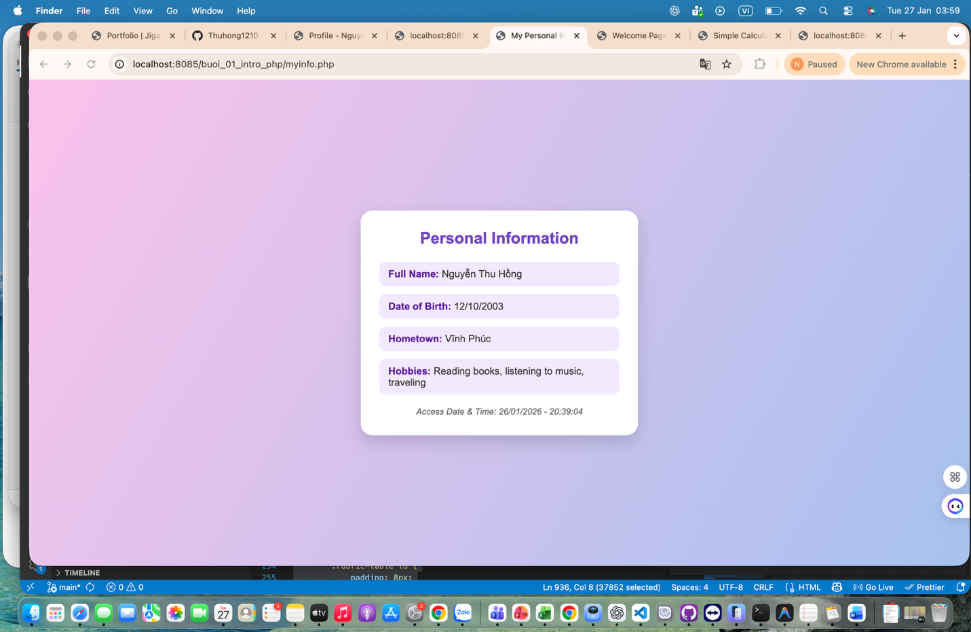

PRACTICAL EXERCISE 2: Welcome Page (Challenge)
🏆 Challenge: Create a welcome page with dynamic information
📝 Requirements:
- Display greeting based on time (Morning/Afternoon/Evening)
- Display day of week in English
- Count days remaining in month
💾 File to Submit: welcome.php
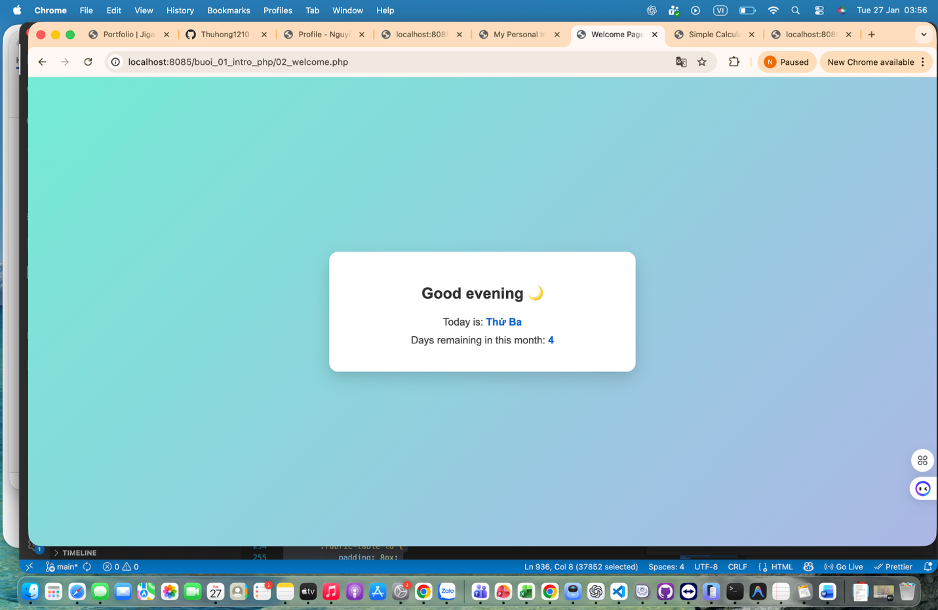

PART D: SELF-ASSESSMENT

D1. Understanding Level (Rate 1–5)
Topic | 1 | 2 | 3 | 4 | 5
Understand what PHP is | ☐ | ☐ | ☐ | ☐ | ☑
Use echo / print | ☐ | ☐ | ☐ | ☐ | ☑
Embed PHP in HTML | ☐ | ☐ | ☐ | ☐ | ☑

D2

D2. Questions Needing Answers
Parts still unclear:

D3. Time Spent
- Theory time: _____60____ minutes
- Practice time: _____90____ minutes

📎 SUBMISSION GUIDELINES
Deadline: [Submission date and time]
How to Submit:
- Save all files in folder: Session01_[Name]_StudentID
- Compress into ZIP file
- Submit via LMS system
Evaluation Criteria:
- Complete requirements correctly: 40%
- Code runs correctly: 30%
- Clean code with comments: 15%
- Complete worksheet: 15%

🔗 PREPARATION FOR SESSION 02
Next Session: Programming PHP - Variables, Data Types, Operators

Knowledge to Learn:
- Variables and declaration
- Data types in PHP
- Arithmetic, comparison, logical operators
- Conditional structures if-else

Preparation:
- Complete Session 01 exercises
- Read ahead about variables in PHP
- Review basic logic knowledge

📚 REFERENCE MATERIALS
Books & Ebooks:
- PHP & MySQL Web Development - Luke Welling
- Learning PHP, MySQL & JavaScript - Robin Nixon
Websites & Tutorials:
- PHP Manual
- W3Schools PHP
- PHP The Right Way
Videos:
- PHP Tutorial for Beginners - YouTube

